**Question 1**

1. Define the term ‘fossil fuel’ (2 marks)  
     
   ____________________________________________________________________________________  
     
   ____________________________________________________________________________________  
     
   ____________________________________________________________________________________
2. Name three fossil fuels and the organisms that they are made from (6 marks)

One: _________________________ made from _________________________

Two: _________________________ made from _________________________

Three: _________________________ made from _________________________

1. Choose one of these fossil fuels and describe the process of fossil fuel formation. (4 marks)  
   - you may use diagrams to support your description.  
    ____________________________________________________________________________________  
     
   ____________________________________________________________________________________  
     
   ____________________________________________________________________________________  
     
   ____________________________________________________________________________________  
     
   ____________________________________________________________________________________  
     
   ____________________________________________________________________________________  
     
   ____________________________________________________________________________________  
     
   ____________________________________________________________________________________  
     
   ____________________________________________________________________________________  
     
   ____________________________________________________________________________________  
     
   ____________________________________________________________________________________

**Question 2**

1. What is it about fossil fuels that makes them difficult to ‘sustainably’ use as a source of energy? (2 marks)  
     
   ____________________________________________________________________________________  
     
   ____________________________________________________________________________________  
     
   ____________________________________________________________________________________  
     
   ____________________________________________________________________________________
2. **List** two negative effects on the environment from the use of fossil fuels. (2 marks)  
     
   ____________________________________________________________________________________  
     
   ____________________________________________________________________________________  
     
   ____________________________________________________________________________________
3. **Describe** one way in which the unsustainable use of fossil fuels has affected the environment. (2 marks)

____________________________________________________________________________________  
  
____________________________________________________________________________________  
  
____________________________________________________________________________________  
  
____________________________________________________________________________________

**Question 3**

The image below depicts the Carbon cycle and the major processes that exchange carbon through the four Earth spheres. Identify the 5 processes and fill them in the table. (5 marks)

1. ___________________
2. ___________________
3. ___________________
4. ___________________
5. ___________________

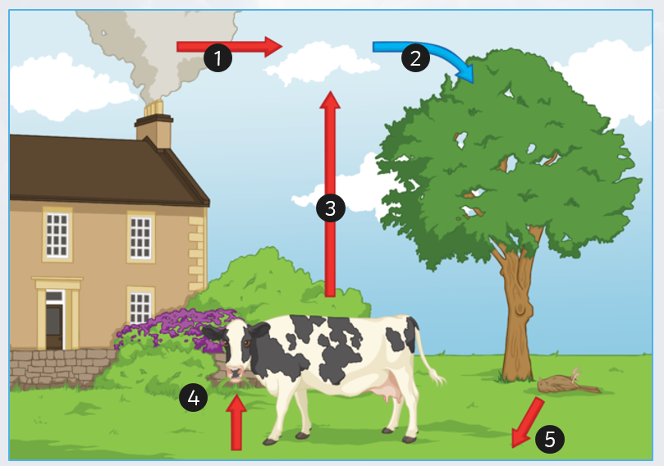

The Enhanced greenhouse effect has been identified as a global problem with far-reaching impacts.

1. Define the enhanced greenhouse effect. (1 mark)

_____________________________________________________________________________

_____________________________________________________________________________

1. List 2 examples of how the enhanced greenhouse effect can be reduced. (2 marks)

i)_____________________________________________________________________________

_____________________________________________________________________________

ii)_____________________________________________________________________________

_____________________________________________________________________________

**Question 4**

The figure below depicts the current estimates for our global ecological footprint, and two possible pathways moving into the future.

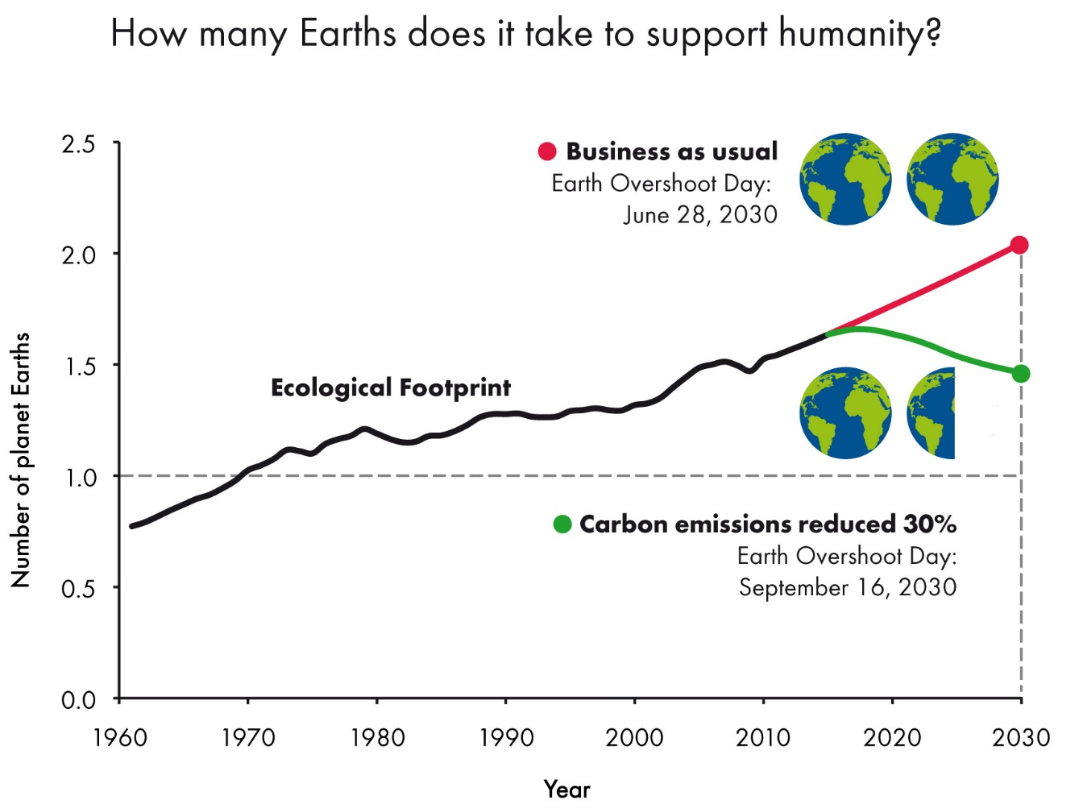

In your own words, and with the help of the graph, discuss the following: (5 marks)

i) What is meant by the term ‘ecological footprint’?

ii) How you would suggest, to people and/or industries, to best reduce our global ecological footprint?  
iii) Why it is important to do so?  
  
_____________________________________________________________________________  
  
_____________________________________________________________________________  
  
_____________________________________________________________________________  
  
_____________________________________________________________________________  
  
_____________________________________________________________________________  
  
_____________________________________________________________________________  
  
_____________________________________________________________________________  
  
_____________________________________________________________________________  
  
_____________________________________________________________________________  
  
_____________________________________________________________________________